***NOAH DRESSLER***

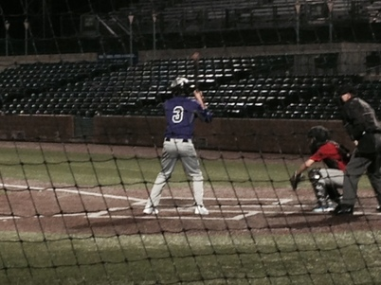

|  |  |  |
| --- | --- | --- |
| ***SCHOOL & ACADEMICS***  Mascoutah Community HS - 2016  GPA:      3.4/4.0 ACT:   Football:      Varsity Letter Quarterback Basketball:  JV Letter Baseball:     JV Letter  Yearbook Staff, Freshman Mentoring Program (FMP), Youth Tee Ball Coach | ***POSITIONS & MEASURABLES***  Catcher / Infield      Bats R / Throws R  6'1 - 165  POP Time:                2.09 Arm Velocity:    Bat Exit Velocity:   60 Time  [NOAH VIDEOS](http://dressler5.net/uploads/3/4/2/5/3425605/noah_dressler.docx) | ***CAMPS & SHOWCASES***   Top Propect Camp      January 2014, Cincinnati, OH  Top 96 Prospect Camp     August 2014, University of Indianpolis  Bellarmine University Prospect Camp     November 2014, Louisville, KY |